odeCommit:

· It is a version Control, just like Git.

· Private Git repository for AWS account, with no size limit on repositories.

Pre-requisites:

1. AWS IAM user.

2. Git Installed.

3. Code for practice: <https://github.com/chxtan/my-webpage>

Now, Follow the steps

1. Goto Aws portal and create an IAM user with administrative permissions.

2. Goto AWS portal and search for Code Commit.

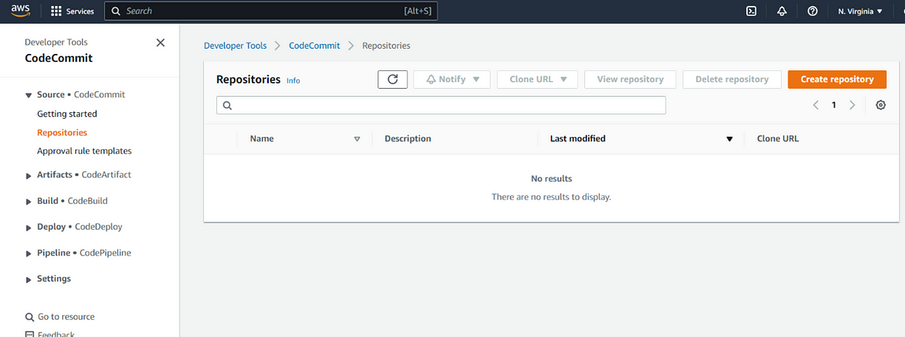

3. Create a repository named: my-webapp and hit create.

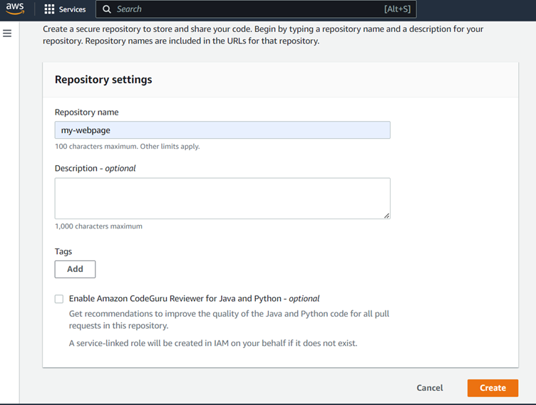

4. After creating the repository, we will go inside it and clone it in local system, by clicking Clone URL > Clone HTTPS.

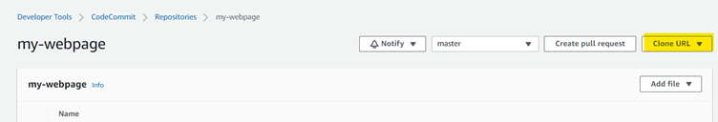

5. Now, Goto your command line in local system and type,

Git clone <URL_copied_from_repo> and it will ask username and password.

Here you need to give the username and password of IAM user that you have created.

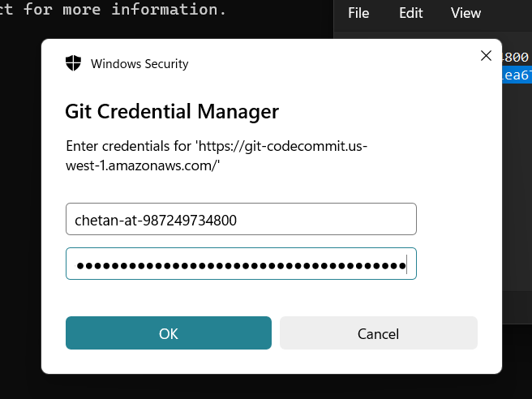

6. And, it will clone an empty repository. Just run “ls -l” command and you will find out an empty directory named “my-webpage”

7. Now, we will push some code in the repository.

8. Copy all the files that you have got from the link “https://github.com/chxtan/my-webpage” and paste inside the folder “my-webapp” that created by cloning the empty repository.

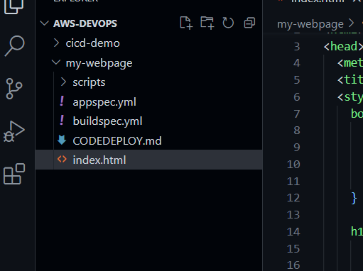

9. Now with command line, browse inside the my-webpage folder and do

“ls”, it will list down all the files inside.

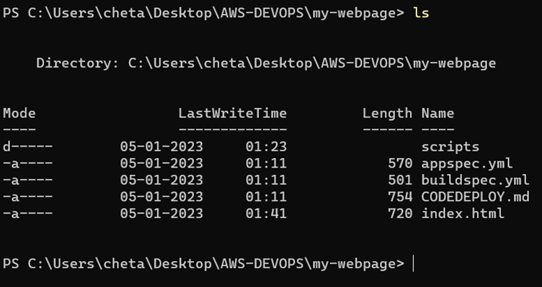

10. Run command “git status” and it will show that all the files are untracked.

11. We will use the “git add .” command to track all the files that were untracked.

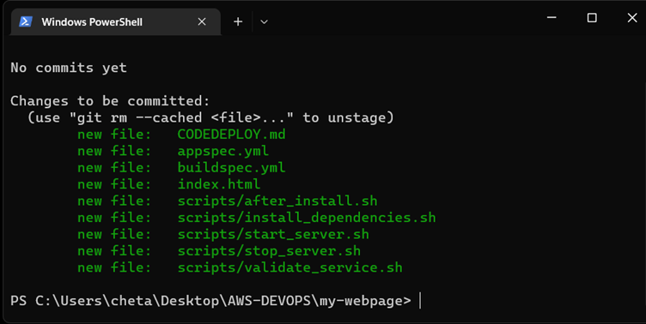

12. Now, we will do the first commit as,

“git commit -m “first commit””

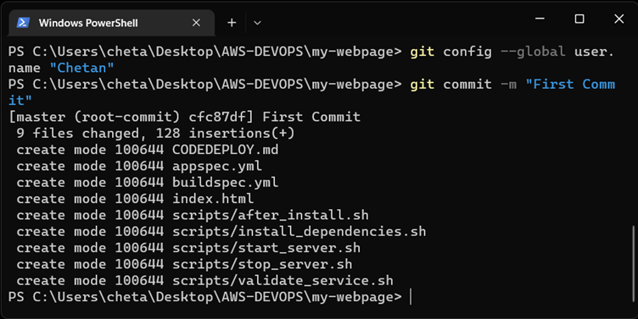

13. We made a commit; it was made locally. Still we need to push our changes to our repository.

14. For that we will use command

“git push”

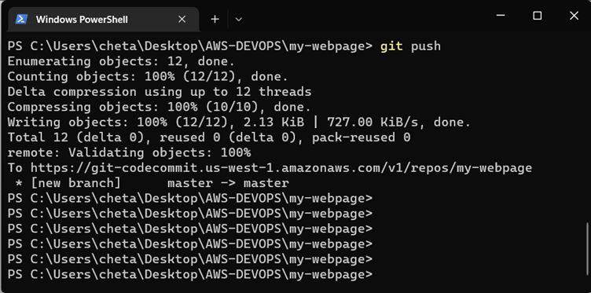

15. And, the code will be uploaded to the AWS repository.

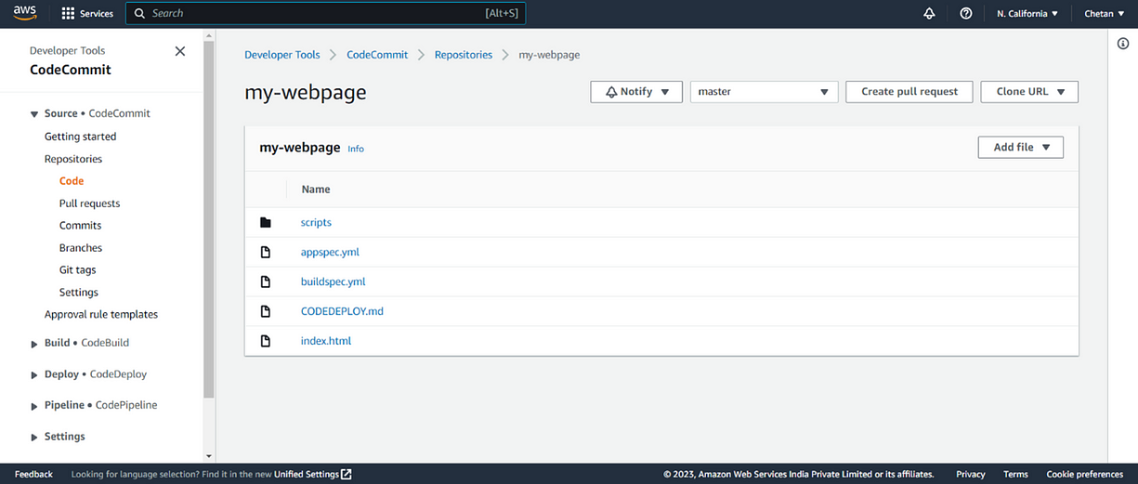

16. Now, we will go to index.html file and modify the content inside.

Suppose, we will change “Congratulations V1” to “Congratulations V2”,

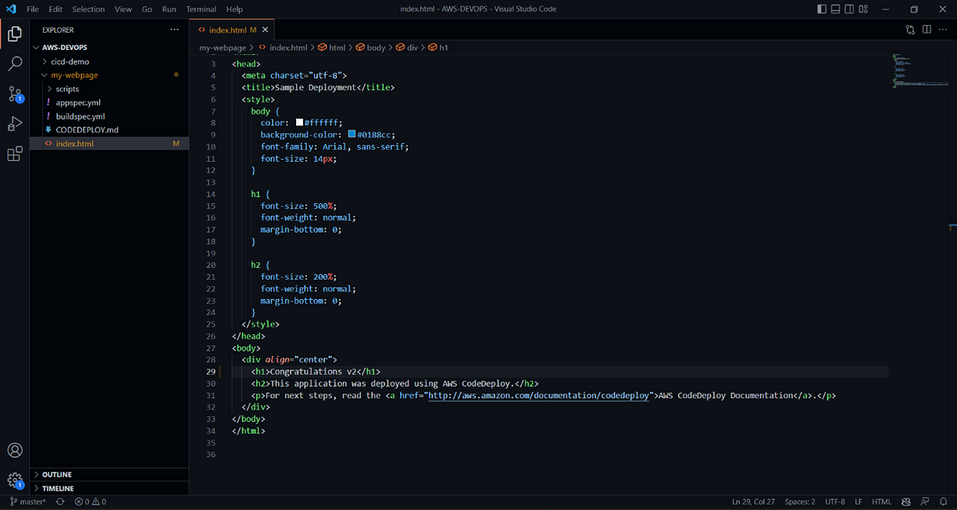

17. And in CMD, we will run “git status” again and the index file will be in untracked category.

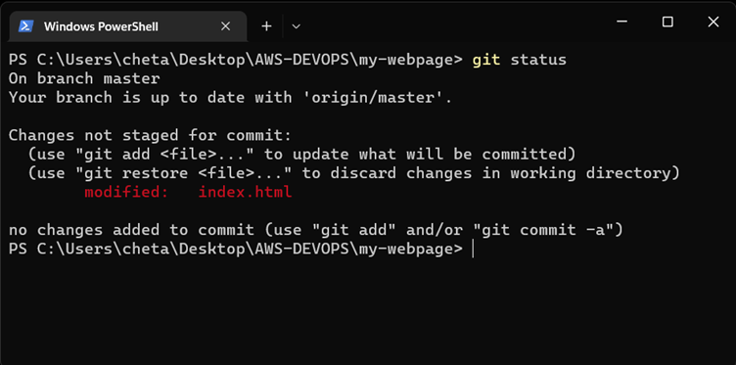

18. To make the file tracked, we will run “git add .\index.html”, and the file will be tracked again.

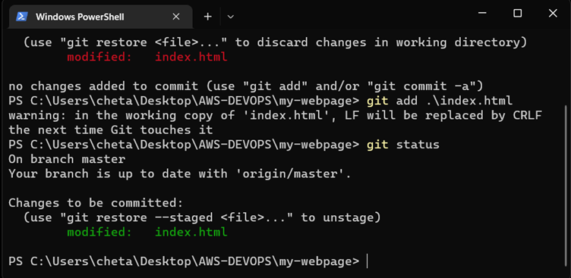

19. And now we will push the file again, with “git push” command.

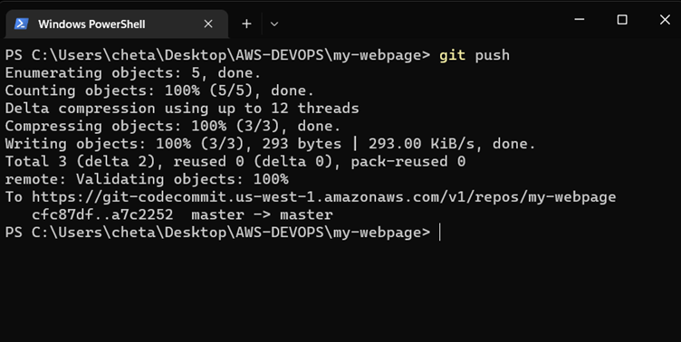

20. We can view the latest commits on AWS portal itself.

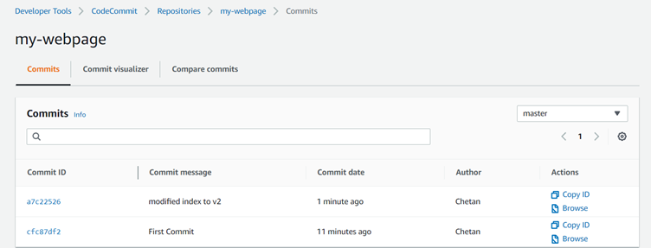

21. We can create a new branch by running, “git checkout -b my-feature”.

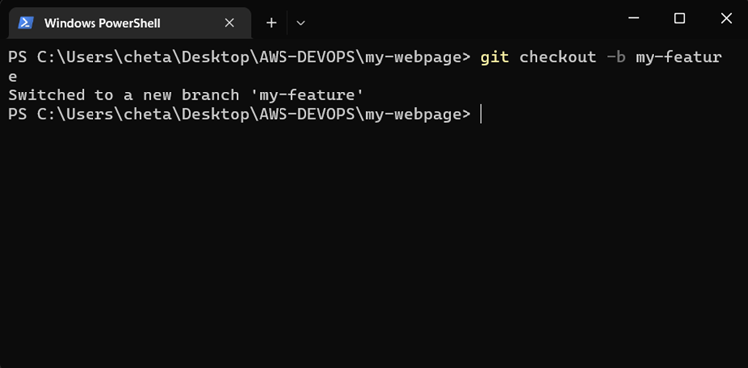

22. Now we will made some changes again to the “index.html” file as “Congratulations V2” to “Congratulation V3”.

23. Run “git status” command and “index.html” will be in untracked mode. Keep in my mind that we are in “my-feature” branch.

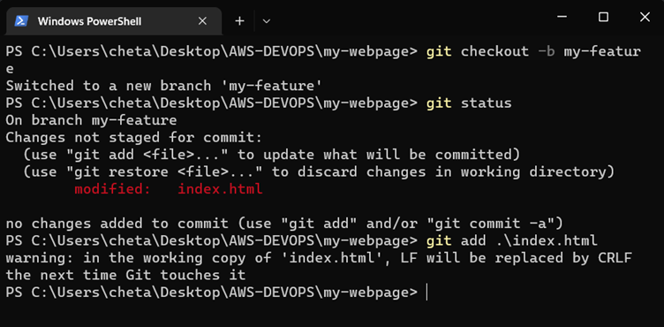

24. Move that file in tracked mode and run the command “git push –set-upstream origin my-feature”.

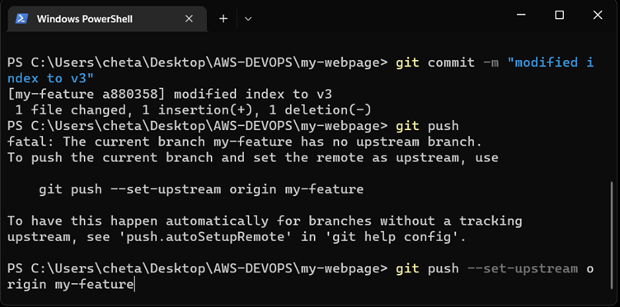

25. Here, in AWS portal, both the branches will be pushed.

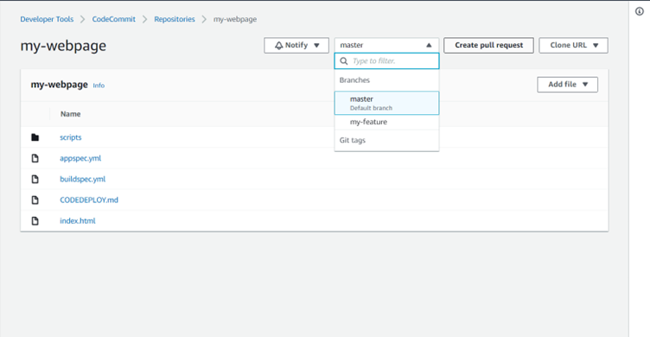

26. Now, we need to add the new feature added that is in “my-feature” branch, for that we will “create pull request”.

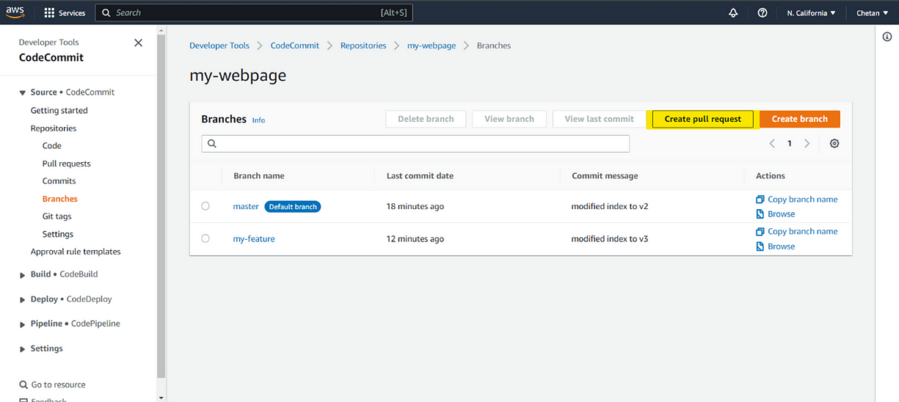

27. Compare the both branches.

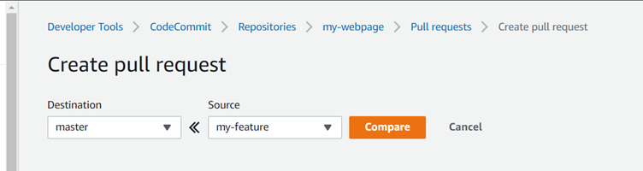

28. And create a pull request.

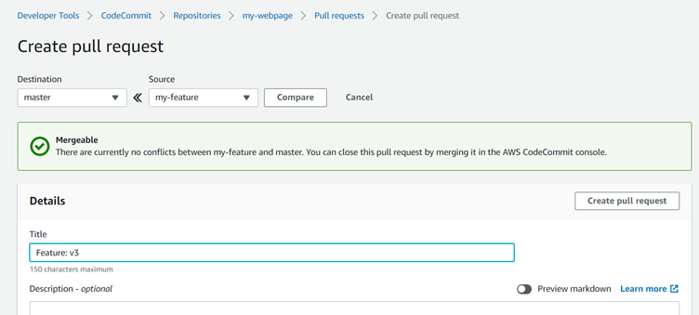

29. Reviewer will Merge this pull request.

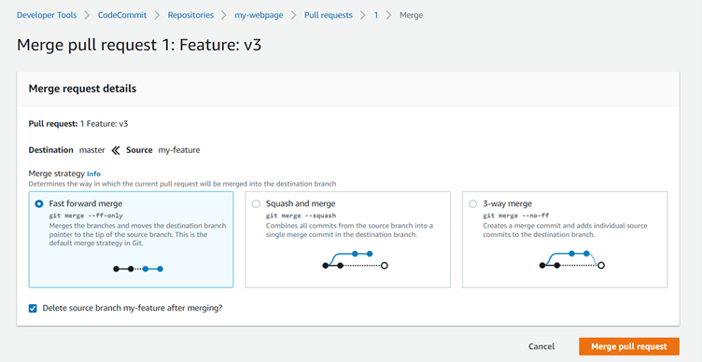

30. And your new feature will be merge in master branch.

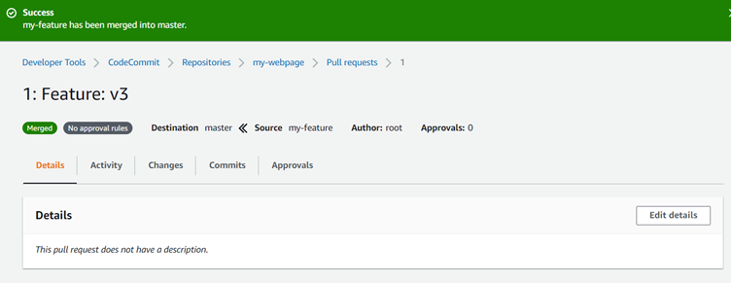

Hope you found this helpful